1. The Task

The task is to create a trellis display chart, using Tableau, showcasing the age and gender demographic information of Singapore’s population in any nine planning areas of choice. The data used to carry out this visualization is ‘*Singapore Residents by Planning Area / Subzone, Age Group, Sex and Type of Dwelling, June 2022’* taken from the [Department of Statistics, Singapore](https://www.singstat.gov.sg/). A detailed account of the steps and procedures for the visualisation needs to be documented along with an analysis of the observations from the visualisation created.

1. Selection Process

Singapore encompasses over 50 planning areas, covering Central, East, North, Northeast and West regions. For this exercise, we were tasked with creating the age-sex pyramid for any nine of the planning areas in Singapore. Hence, the criteria selection for this was imperative. The ideal selection for me was to pick the top most populated planning areas as it would be interesting to identify the distribution of the male and female population across different age groups at a granular level. The top 9 populated planning areas were Yishun, Ang Mo Kio, Bedok, Choa Chu Kang, Hougang, Jurong West, Sengkang, Tampines and Woodlands.

Additionally, the dataset provided had a five-year band for each age group such as 0 – 4, 5 – 9,….80-84, 85 & Over. This resulted in eighteen categories for age groups. For a user, this is a lot of information to take in with nine different graphs. Hence, for better grasping power, it is better to reduce the categories within age groups. To identify the age group combinations, I referred to IndexMundi and National Statistics Standard and classified the age group as mentioned below:

1. Step-by-Step Description

3.1 Data Processing

1. Downloading the dataset

From the main dataset downloaded, the datasets extracted for our age-sex pyramid are, ‘Population of Males by Age Groups and Planning Areas’ and ‘Population of Females by Age Groups and Planning Areas.’

1. Data processing

The data was cleaned for both ‘Population of Males by Age Groups and Planning Areas’ and ‘Population of Females by Age Groups and Planning Areas’ in MS Excel. The‘Planning Area’ sections by ‘Age’ were combined. The cleaning process entailed removing the the ‘Total’ columns using ‘command + -‘. Additionally, the empty cells between each planning area were filled such that each subzone had a corresponding planning area alongside.

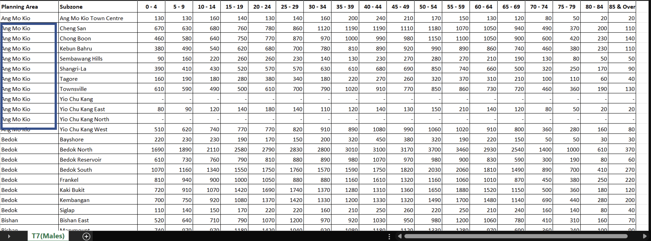

1.3. Pivoting the worksheets in Tableau

1. It is desirable to have data structured as long and lean for better analysis in Tableau. Hence, the short and wide data structure in MS Excel worksheets was opened in Tableau, and all the five-year age bands were pivoted to the long and lean data structure. This process is done for both the male and female worksheets.
2. Load the ‘Population of Males by Age Groups and Planning Areas’ saved as ‘Male Population’ and ‘Population of Females by Age Groups and Planning Areas’ saved as ‘Female Population’ onto Tableau separately.

1. In ‘Data Source’, select all the age groups from ‘0-4’ to ’85 & Over’ using the ‘shift’ key and then go to drop down arrow next to ‘Abc’ under any of the age groups and select ‘Pivot’

1. Go to ‘Data’ and select ‘Export Data to csv’, ensure that this process is completed for both the ‘Male population’ and ‘Female population’.

1. The column names retained in each MS Excel worksheets post pivoting were ‘Planning Area’, ‘Subzone’, ‘Age’ (for five-year age bands), ‘Gender’ (Male or Female, depending on the data worksheet), and ‘Population’ (population count). Additionally, add another column and call it ‘Gender’ and put ‘Male’ and ‘Female’ according to the worksheet required.

1. 5. Then combine these workbooks as separate sheets in another workbook, saved as ‘SG Population by Subzone’

2. Creating the Tableau Dashboard

2.1. Union of Male and Female datasets

1. Relaunch Tableau and load the newly created MS Excel workbook ‘SG Population by Subzone’ which will display the ‘Male Population’ and the ‘Female Population’ sheets. Click on ‘New Union’ and in the dialog box that appears, drag the two sheets therein and click ‘OK’.

2.2. Creating new variables for 3*3 panel charts

2.3. Creating new variables aggregating the female and male population

2.4. Performing table calculations for proportions

2.5. Enhancing the Aesthetics

2.6. Creating the final dashboard

1. Observations and Insights

Notes: Total population here refers to the population of the nine planning areas highlighted in the chart above.

Key Finding 1:

From the age-sex pyramid, we can discern with certainty that Singapore has a constrictive population pyramid. This chart appears like a beehive, protruding in the middle and tapering down towards the younger and older population. These charts display smaller proportions of the younger population thereby depicting a population that is ageing and shrinking. These population pyramids are a common phenomenon in highly developed countries with low birth rates and low death rates. Countries with such a constrictive age-sex pyramid indicate that the population is increasing in high social and economic development with better access to education and healthcare for most of the population. The ageing population of Singapore is a concern for the government as being a small nation with limited resources, the ageing trend will impact Singapore more acutely. They have introduced policies such as ‘Made for Families’ to support and encourage Singaporeans towards marriage and parenthood. Additionally, policies such as ‘The Refresh of the Action Plan for Successful Ageing and population’ helps empower the aged population.

Reference: <https://study.com/academy/lesson/population-pyramids-definition-types-stages.html>

<https://countrymeters.info/en/Singapore>

<https://www.strategygroup.gov.sg/files/media-centre/publications/Population-in-Brief-2022.pdf>

Key Finding 2:

One can see a uniform spread through the age profiles across the board, with minute variations observed across the nine planning areas. The dominant age profile is the ‘primary working age’ (PWA) population (aged 25 - 54), accounting for 46.55% of the total population. Children (aged 0 – 14) account for roughly 16% of the total population.

1. **A higher proportion of PWA and children population in Sengkang, Jurong West and Woodlands:** Sengkang records the highest PWA and children population, closely followed by Jurong West and Woodlands, making them the most sought-after dwelling area by the **active** working population. This can be attributed to the higher presence of children-bearing families that are leveraging the high connectivity of public transport to the central region whilst paying comparatively lower rental rates for the residential properties in these areas.
2. **A higher proportion of ‘Elderly’ and ‘Oldest-Old’ and a lower proportion of ‘PWA’ and ‘children’ populations in Bedok, Ang Mo Kio, Hougang:** The elderly and oldest-old populations account for the lowest proportion in the overall age profile and are more densely populated in Ang Mo Kio, Bedok and Hougang whereas their presence in the planning areas mentioned in 2 (a) is the least. These areas also form a V shape indicative of a higher elderly and aged population indicative of the fact that there is a higher aged population in those areas. These places have abundant amenities that tailor to the needs of the elderly such as coffee shops, marketplaces and leisure places where the aged population can socialise with one another.

Reference: <https://www.tp.edu.sg/schools-and-courses/students/schools/bus/about-bus/storiesco/life/ageing-in-place.html>

Key Finding 3:

As we can see in the graphs above, the proportion of females across most age profiles and planning areas is higher than males, albeit marginally. The proportions are relatively equal among the ‘Early Working Age’, ‘Primary Working Age’ and ‘Mature Working Age’ populations.

1. **Higher Proportion of Females in the elderly and oldest-old categories:** There is an increasing trend for the female population increasing post the age of 65, whereas the converse is true for the male population. This clearly implies that female life expectancy is longer than men’s. In fact, this trend has been observed in Singapore since 2010 (<https://www.singstat.gov.sg/-/media/files/publications/population/population2021.pdf> page 46). This difference is more pronounced in areas such as Bedok, Ang Mo Kio, Hougang and Yishun.
2. **Lower Proportion of Females in the ‘Children’ population:** The proportion of children that are males is higher across the board in the ‘children’ category which could be indicative of higher infant mortality rates for females. This difference is more pronounced in Sengkang, Tampines, Jurong West and Woodlands.